**TABLEAU PROJECT**

**INTRODUCTION :-**

We have a data of orders that customer had bought, thorough this data we can have a overview of the sales, profit in respect to country, region, state. By this we can have the pictorial representation of states or region where we have highest sales through this we can analyse demand and supply of products in particular region or state which will bring conclusion to understand demand and supply accordingly.

**METHODOLOGY :-**

From the data we had made an analysis on the number of sales, tax, net revenue, profit and loss. We had sorted the data in way through which we can make an analysis on which region , state, category, sub category, year have highest and lowest sales accordingly.

**REQUIREMENT ANALYSIS :-**

We need to analyze which region, segment, category and year have high positive numbers and for which product. We need to capture region and product wise demand so that we can increase our supply for the region.

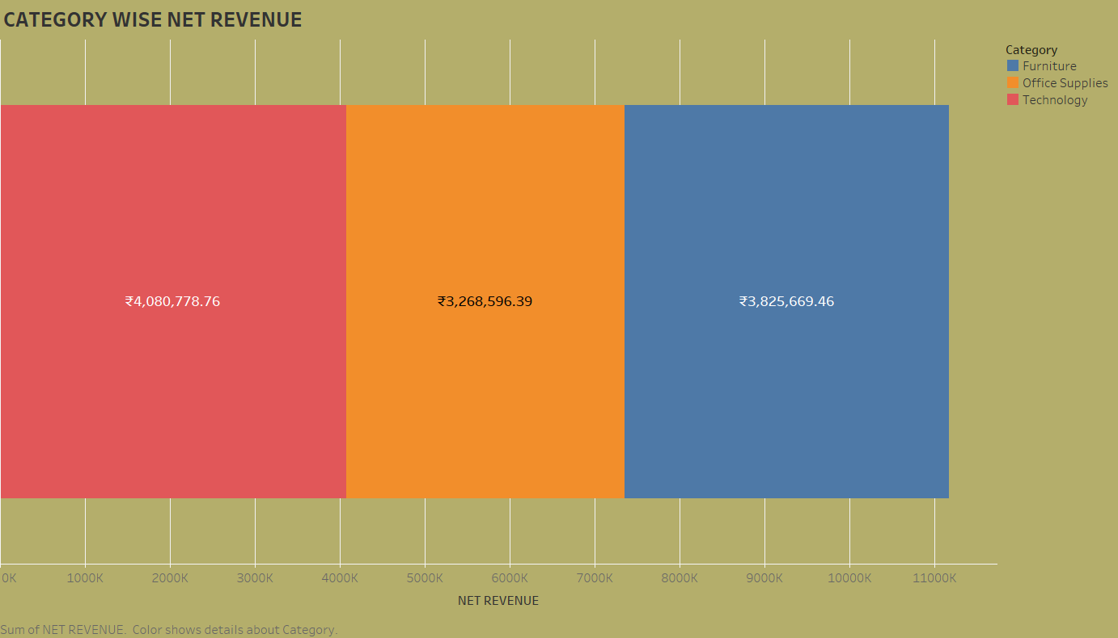In this we can see that we are having net revenue of Rs4,080,778.76 from technology category which means our technology category products are performing well and along with that we have a good no. for furniture category as well, but we need to focus more on lowest which is office supplies.

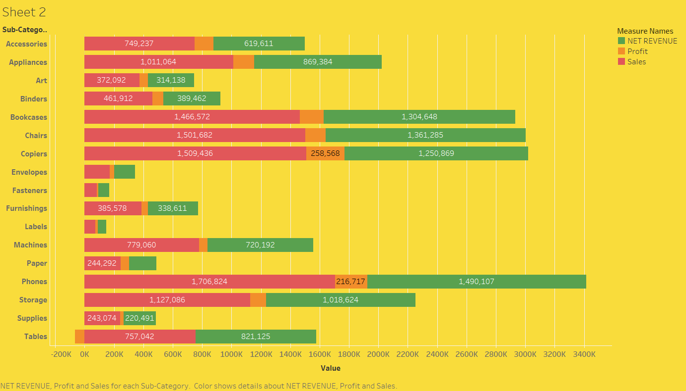

According to this we have highest net revenue and sales of Rs 1,490,107 through Phone and lowest for Labels but are also getting negative value of profit by Table sub category.

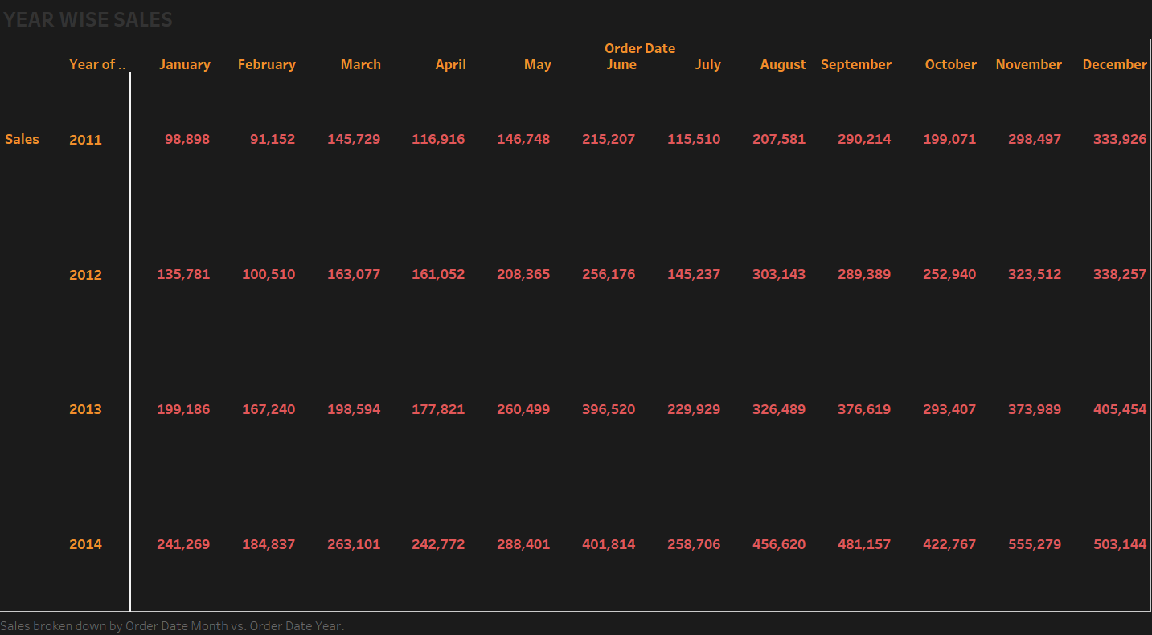

Over here we can see that our sales are increasing every year that means all over we are performing good in terms of marketing and sales. We have highest sale in November 2014 of Rs 555,279.

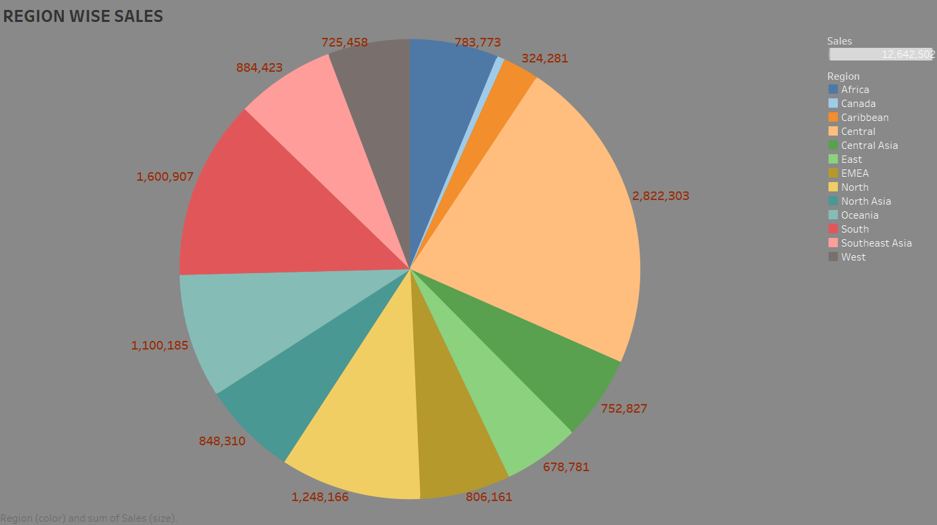

We have massive sales in Central Region we have done sales of Rs 2,822,303 also if we need to find out sales for particular state there is filter for the same, we can select the states and get the results accordingly. Lowest no. of sales is in Canada Region of Rs 66,928

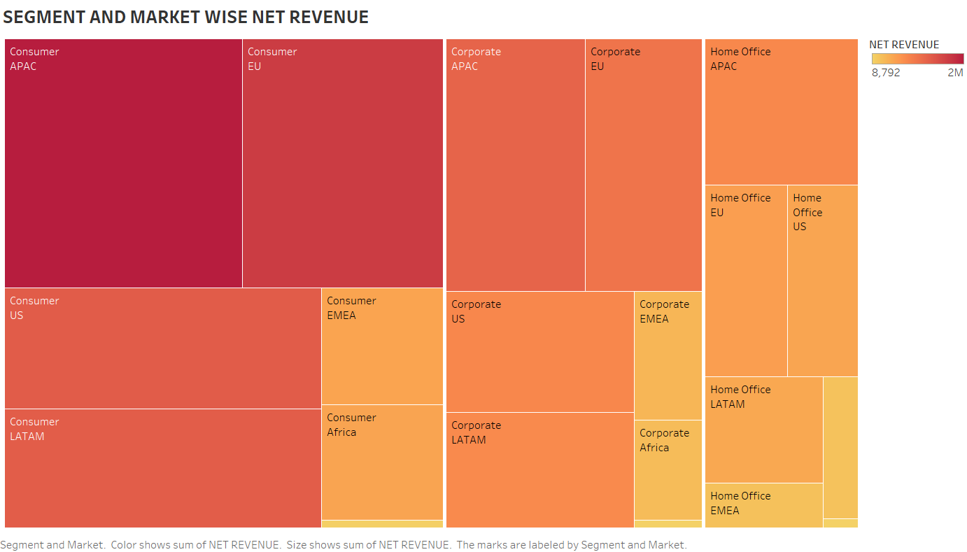Through this we can understand that how each segment is performing in the market. As here we can see our highest net revenue is generated by consumer segment in APAC

Market but Home Office Segment is lowest in that market likewise we can find out for each market which segment is doing great and which needs to be discussed to improve their sales.

**CONCLUSION :-**

By this we can conclude that our sales are increasing year by year but profits do have fluctuating pattern we have highest sales in 2014. Also we have lowest sales in Canada region so we need to do survey on why we are not able to achieve numbers in that region and along with that we need to deeply analyze all the regions and the make our strategies accordingly, and same we need to do with segment and market to increase profit numbers.